Questions 1 – 3, evaluate each piecewise function.

1. $A\left(x\right)=\left\{\begin{aligned}-x+4, x≤-2 \\ x-2, x>2\end{aligned}\right.$

a. $A(-4)$ b. $A(-2)$ c. $A(0)$ d. $A(2)$ e. $A(5)$

2. $B\left(x\right)=\left\{\begin{aligned}x-3, x<-6 \\ { x}^{2}, -4≤x<3 \\ 7, x>3\end{aligned}\right.$

a. $B(-7)$ b. $B(-2)$ c. $B(2)$ d. $B(3)$ e. $B(5)$

3. $C\left(x\right)=\left\{\begin{aligned} x+2, x≤-5 \\ \left|x-3\right|+4, -5<x<3 \\ -x, x>3\end{aligned}\right.$

a. $C(-6)$ b. $C(-5)$ c. $C(-2)$ d. $C(1)$ e. $C(4)$

Questions 4 – 7, graph the piecewise function and state the domain and range.
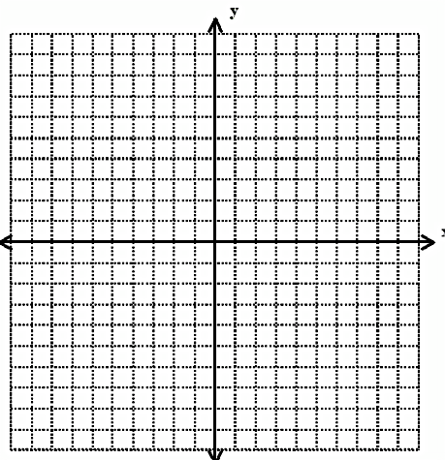

4. $D\left(x\right)= \left\{\begin{aligned}1, x ≤-1 \\ x+1, x>3\end{aligned}\right.$

Domain:

Range:

5. $E\left(x\right)= \left\{ \begin{aligned}|x|, x ≤1 \\ 2x+3, x>1\end{aligned}\right.$

Domain:

Range:

6. $F\left(x\right)=\left\{\begin{aligned}-2, x≤-5 \\ x+5, -3≤x<3 \\ { (x-5)}^{2}+1, x>3\end{aligned}\right.$

Domain:

Range:

7. $G\left(x\right)= \left\{\begin{aligned}4, x<-2 \\ x^{2}, -2≤x≤2 \\ -x, x>2\end{aligned}\right.$

Domain:

Range:

